**Sentence Transformer Model Testing**

**Model Information:**

Model name: Alibaba-NLP/gte-Qwen2-1.5B-instruct

Max sequence length: 512 (Max: 8192)

Model Size: 1.5B

Embedding Dimension: 1536

Max Input Tokens: 32k

Size on disk: 6.62GB

**Testing Platform:**

Platform name: Google Colab

Device: T4 GPU

**Dataset Description:**

**Dataset 1:**

Number of queries: 10

Average query length: 65 characters

Number of documents: 10

Average document length: 410 characters

Language: Nepali

**Dataset 2:**

Document type: PDF

Language: Nepali

Number of pages: 100

**Evaluation Metrics:**

Latency: The time taken to embed the given text.

Memory usage: The memory utilization during embedding.

**Time Measurement Technique:**

The following decorator function was used to measure execution time:

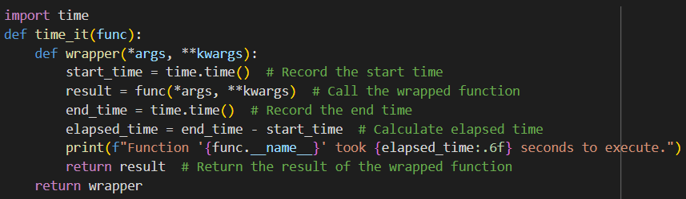

**Results:**

**GPU memory usage for model:**

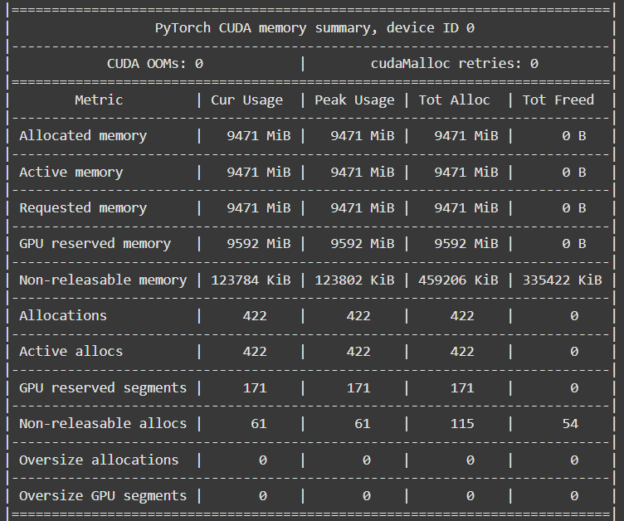

Memory Usage: 9471 MiB

**Time and Memory Evaluations:**

**For Dataset 1**

|  |  |  |
| --- | --- | --- |
| **For** | **Time** | **Memory usage** |
| 1 query embedding | 0.208867s | 10 MiB per page |
| Batch of 10 queries | 0.650527s | 35 MiB |
| Multithreaded 10 queries | 1.425632s | 10 MiB per thread |

**For Dataset 2**

**20 pages**

|  |  |  |
| --- | --- | --- |
| **For** | **Time** | **Memory usage** |
| 1 page embedding at a time | 9.21s | 32 MiB per page |
| Batch embedding of 20 pages | 7.881586s | 621 MiB |
| Multithreaded with 6 threads | 8.479194s | 186 Mib per thread |

**100 pages**

|  |  |  |
| --- | --- | --- |
| **For** | **Time** | **Memory usage** |
| 1 page embedding at a time | 45.602843s | 32 MiB per page |
| Batch embedding 100 pages (25 per batch) | 36.929543s | 2422 MiB per batch |
| Multithreaded with 6 threads | 37.447301s | 176 MiB per thread |
| Batch Multithreaded with 6 threads (4 per batch) | 9.793176s | 724 MiB per thread |

**Embedding Evaluation:**

**Similarity Matrix**

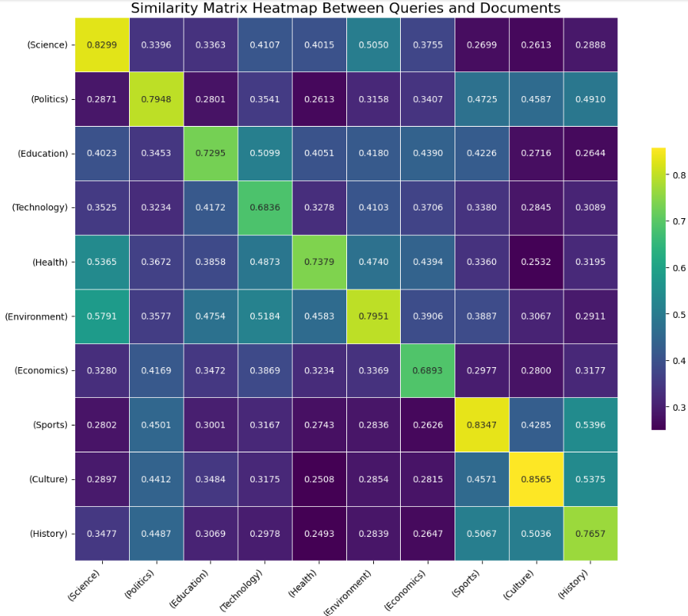

The similarity matrix shown in the figure above provides a heatmap representation of the similarity scores between 10 queries and 10 corresponding documents. Each cell in the matrix represents the similarity score between a specific query and a document, where higher values indicate greater similarity.

**Key Observation:**

* The diagonal entries of the matrix consistently exhibit the highest similarity scores. These entries represent cases where queries are matched with their corresponding documents (e.g., Science query to Science document, Politics query to Politics document).
* For example, the similarity score for "Science" is 0.8299, and for "Sports," it is 0.8347, indicating strong alignment between queries and documents in these categories.

**Findings:**

**For Query dataset**

* Batching results in significant increase in processing speed with moderate increase in memory usage.
* Multithreading resulted in higher processing time compared to batching, likely due to thread synchronization overhead, despite lower per-thread memory usage.

**For PDF dataset**

* Embedding single page at a time is memory efficient but highly time in-efficient.
* Batching improves processing time but requires significantly more memory.
* Multithreading reduces memory usage compared to batch embedding but shows marginally higher time due to thread overhead.
* Combines the benefits of batching and multithreading, significantly reducing processing time and optimizing memory usage.

**Recommendations:**

* For small datasets (e.g., single queries or pages), single embedding is sufficient.
* For medium-sized datasets, batching without multithreading is effective but memory-intensive.
* For large datasets, batch multithreading is the optimal choice to balance time and memory usage.

**Conclusion:**

The **Alibaba-NLP/gte-Qwen2-1.5B-instruct** model exhibits excellent semantic representation capabilities, as evident from its ability to produce high similarity scores between related queries and documents. Its efficient handling of diverse input queries and adaptability for batching and multithreading make it a robust choice for large-scale embedding tasks and retrieval systems. However, its high memory usage indicates that it is best suited for environments with adequate computational resources.